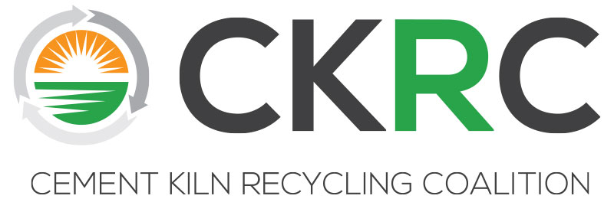

CKRC Executive Committee Meeting
Monday, October, 2018 * 3:30-6:00 pm
Lansdowne
44050 Woodridge Pkwy, Leesburg, VA 20176
Agenda

I Call to Order/Antitrust Agreement and Welcome Newly Elected Committee
Member/Co-Chairs (Steve Holt) 3:30pm

II Approval of EC Minutes Spring 2018 (Committee) 3:35pm

III Financial Reports (Michelle Lusk) 3:40pm
- Dues Payment Report (Receivables)
- Budget vs Actual Final for FY 17/18
- Budget vs Actual Current FY as of September 30, 2018

IV Presentation and Approval of CKRC Financial Statements and Independent Accountants’ Review Report for FY Ended June 30, 2018 (Michelle Lusk/Steve Holt) 3:45pm

V Presentation of Options to Honor Craig Campbell’s Memory (Michelle Lusk/Committee Discussion) 4:00pm

VI MSHA Meeting and CKRC Response -- Formulation of Big Picture Strategy/Direction for Tech/Reg Committee (Michelle Lusk, Mike Harrell, Steve Reale/Committee Direction) 4:30pm

VII USEPA Coordination Effort on Opiate Destruction Survey Summary and Preparation for Discussion with Barnes Johnson during FMM (Michelle Lusk/Committee Discussion) 5:15pm

VIII Upcoming Meetings – (Michelle Lusk) 5:45pm
- Spring 2019
- Fall 2019

IX New Business (Committee) 5:55pm

X Adjournment (Steve Holt) 6:00pm

