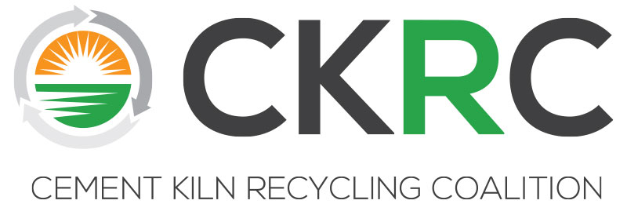

CKRC Fall 2018 Meeting
October 1-3, 2018
Lansdowne
44050 Woodridge Parkway
Leesburg, VA 20176

Agenda

MONDAY, October 1
1:00-3:00 pm Team Building Event – Footgolf
Foot golf is located on the Sharkbite course. Everyone signed up for the event should meet in the golf cart staging area between the hotel and the clubhouse just before 1pm to learn how foot golf works and then be led to the course.

3:30-5:30 pm Executive Committee Meeting (See Separate Agenda sent to EC)

6:30 pm Welcome Reception and Dinner – Wine Tasting Experience/Presentation

VA Vine to Wine: The story behind the bottles!
Hailey Zurschmeide
Bluemont Vineyard - General Manager
Loudoun Wineries Association - Treasurer

TUESDAY, October 2
8:00 am Breakfast Buffet Available

9:00 am Call to Order/Antitrust/EC Meeting Update

9:10 am Navigating the New CKRC Website
Michelle Lusk – CKRC

9:30 am Legal Update
Lisa Jaeger – CKRC Counsel, Bracewell, LLP
(CAA: NAAQS, NSR/PSD, Climate/GHG, CISWI, NESHAPS RMP, Methane, Regional Consistency, 608 Refrigerant Mgmt; Water: NPDES, CWA; RCRA Litigation; CERCLA Legal; Administration Regulatory Reform)

11:00 am Guest Speaker – Barnes Johnson, USEPA, Director, Office of Resource Conservation and Recovery (ORCR)
(CERCLA FA, E-manifest, Pharmaceutical Waste Policy, Volunteer Initiative, Coal Ash and Definition of Solid Waste Decisions; CISWI MACT Decision)

12:00 noon Lunch
1:00 pm Regulatory Issue Wrap-up
Jim Berlow – Consultant
(Wrap-up on CERCLA, Definition of Solid Waste, E-manifest, Volunteer Initiative, and others)

1:30 pm Industry Panel on MSHA Compliance – The panel speakers will present various perspectives on MSHA compliance and the recent MSHA inspection initiative to both educate the membership and prepare those participating in the MSHA Response-focused Technical/Regulatory meeting scheduled for Wednesday morning. Panelists will make presentations, there will be time for questions, and we hope there will be some good interactive discussion on the topic.
Recent MSHA Inspections: A Facility’s Perspective – Talya Mayfield, Environmental Health and Safety Manager, Green America Recycling, CKRC Member

Assessing and Controlling Chemical Exposures -- David Comen, Founder and President of Artisan EHS Consulting, LLC, Certified Industrial Hygienist and Certified Hazardous Materials Manager, B.S. in Chemistry and studied Occupational Health and Safety
Steps to develop a MSHA Compliance Demonstration for Alternative Fuels -- Janice Timpson, Senior Project Manager for Business Central 2, Inc. and Consultant to EARTHManagement, LLC (EM), Authorized OSHA General Industry and Construction Safety Instructor, B.S. in Occupational Safety and Health

3:30 pm Break

3:45 pm Upcoming Technical/Regulatory Efforts
CKRC Spring Technical Workshop Part II -- Issue Identification
Cement 101 Website Links – Break-Out Session
Future Planning – Issue/Project Brainstorming

5:00 pm Adjourn

TUESDAY NIGHT, October 2
6:00 pm Reception

7:30 pm Dinner
Guest Speaker – Political Outlook, Scott Segal, Bracewell, LLP

WEDNESDAY , October 3
8:00 am Buffet Breakfast Available

9:00 am Technical/Regulatory Committee Meeting
Preparing for Fall CKRC/MSHA Meeting to Educate the Agency and Exchange Information
--EC Direction for the Committee
--Relevant Information to Date
--Development of Action Plan/Format/Outline for Meeting
--Substance and Participants
--Additional Preparation Meetings/Calls, Next Steps

12:00 noon Boxed Lunches Available

1:00 pm Golf Outing on the Lansdowne RTJ Course

