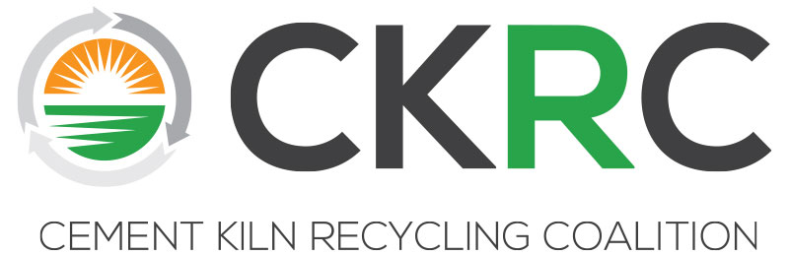

CKRC Executive Committee Meeting
Monday, April 16, 2018 * 2:30-4:30 pm
The Grand Bohemian Hotel
55 Wentworth St, Charleston, SC 29401
DRAFT Minutes

Participants: Steve Holt, Curtis Lesslie, Chuck Kellett, Joseph Marini, Michelle Ferguson, Dan Nugent, Tim Matz, Brian Wilson, Mike Harrell, Ken Derksen, Tim Schlosser and Michelle Lusk. Presenters included Lisa Jaeger, Steve Reale and Jim Berlow.

I Call to Order/Antitrust Agreement
Chairman Steve Holt called the meeting to order and reminded the committee that the meeting would be conducted in accordance with the CKRC antitrust statement and in accordance with all CKRC policies.

II Approval of EC Minutes Fall 2017 NYC
Michelle Lusk presented the draft minutes from the fall 2017 meeting in NYC. Chuck Kellett made a motion to approve the minutes. The motion was seconded by Curtis Lesslie and the motion carried unanimously.

III Financial Reports
Michelle discussed new member possibilities including Trioxy (Greg Haug) and Tradebe Rejoining (Tita Lagrimas). Several EC members agreed to reach out and touch base with them and encourage them to consider joining CKRC. Tim Schlosser agreed to call Greg Haug and Ken Derksen and Steve Holt agreed to reach out to Tita Lagrimas to encourage her company to rejoin.
Michelle Lusk presented the Budget vs. actual and noted that all major categories for the FY are under budget. Meetings not representative at this time as the final hotel bill has not been paid. M. Lusk explained that next year’s budget will be developed in May by working with the treasurer and officer review. The officer recommended budget will be distributed to the full committee for approval in June so invoices for FY18/19 can be mailed by July 1, 2018.
Michelle Lusk raised some preliminary ideas about how CKRC could honor Craig Campbell’s memory. The discussion raised options related to education and environmental protection; both his alma maters were identified (Bucknell and GW). There was discussion about a call for papers on topics of interest, and inviting the winner to a CKRC meeting with scholarship. One-time donations to university; multi-year scholarships, endowments, and a charity-type donation were discussed. Michelle Lusk will do research and prepare a list of options for the next meeting.
Michelle Lusk mentioned that in the next fiscal year it may be prudent to review the By-laws to see if any necessary changes be made. One may be in the listing of standing committees (section 2). Dan Nugent mentioned that he thought the By-laws had been reviewed and revised later than the 2003 date. Prior to any by-laws review, Michelle will research past minutes to confirm date of last revisions.
Michelle asked the committee for direction/identification of new projects for the next FY budget development process. Both MSHA and future Technical Workshops come to mind. Michelle asked that members contact her with ideas or issues of interest for budget purposes within the next few weeks.

IV Website Upgrade Project Update
Michelle Lusk explained that some of the website pictures needed to be reconfigured, supporting citations tracked down, and some language tweaks made. Efforts will be made to get all this done and take the website live as soon as possible.

V Upcoming Elections
Michelle Lusk notified the group that the call for nominations for new EC officers is out. Those elections along with the nomination process and election of an at-large EC representative and Technical/Regulatory Committee officers will take place over the summer.

VI HWC MACT Database Update & Test Data/Analysis Template Presentation
Steve Real of SYA presented on HWC MACT database update. He explained that the last update was in 2016 and that his new 2018 update has new data from nearly every facility. He also discussed and presented the streamlined data collection template. The hope is that companies would use it to fill out and provide their data to CKRC in the future. Steve Reale recommends biennial updates to the database consistent with practices over the last few years.

VII Executive Committee Briefing
Lisa Jaeger provided an executive briefing on EPA issues, the new deputy administrator Andrew Wheeler, Executive orders, and other upcoming big picture issues.

VIII USEPA Coordination Effort on Opiate Destruction
Jim Berlow discussed a potential EPA volunteer partnership effort on opiate destruction. Law enforcement is having trouble finding locations to destroy confiscated opiates. EPA wants to build a voluntary network of combustion facilities including kilns with RCRA permits. It is a preliminary Agency idea and the Agency wants to know if CKRC members are interested? Discussion ensued. Michelle Lusk agreed to survey members to get an idea of interest, concerns, regulatory hurdles, and desired incentives.
IX Upcoming Meetings
Michelle Lusk discussed upcoming meetings. The fall meeting will be in the DC area and an effort will be made to coordinate it around PCA’s E&E meeting scheduled in DC on October 4th since several members will be attending that meeting as well. Michelle requested that ideas for next spring 2019 (Weeks of April 8-10, 29-May 1) be emailed to her. Michelle stated she is looking for input on location as well as conflicting dates.
X New Business
There was no new business raised.

XI Adjournment
Chuck Kellett made a motion to adjourn the meeting and the motion was seconded by Brian Wilson. The EC unanimously voted to adjourn the meeting at 5pm.

