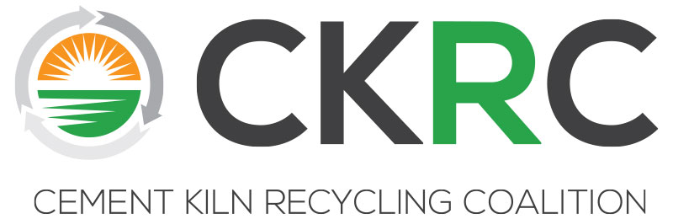

CKRC Executive Committee Meeting
Monday, April 1, 2019 * 3:00-5:00 pm
The Wigwam Hotel -- Palo Verde Room
300 East Wigwam Blvd., Litchfield Park, Arizona 85340, 866.976.6894

Agenda

I Call to Order/Antitrust Agreement and Welcome
(Curtis Lesslie) 3:00pm

II Approval of EC Minutes Fall 2018 (Committee) 3:05pm

III Financial Reports (Michelle Lusk) 3:10pm
- Dues Payment Report (Receivables)
- Budget vs Actual

IV Financial Exploratory Task Force Recommendation (Michelle Ferguson/Dan Nugent) 3:15pm
- Cash Surplus Dues Rebate Concept

V Progress Update on Scholarship in Craig Campbell’s Memory (Michelle Lusk) 3:45pm

VI December MSHA Meeting Update (Michelle Lusk, Curtis Lesslie) 4:00pm

VII Update on March USEPA Exploratory Meeting on Potential Voluntary Confiscated Drug Initiative (CDI) (Dan Nugent/Steve Holt/Michelle Lusk) 4:15pm

VIII Technical/Regulatory Workshops (Mike Harrell/Michelle Lusk) 4:30pm
- Broader Outreach
- Issue Specific Webinars

IX Upcoming Meetings – (Michelle Lusk) 4:45pm
- Fall 2019 – Wednesday, October 23rd-Friday, October 25th
The Desoto Hotel, Savannah, GA

- Spring 2020 – Monday, April 20th-Tuesday, April 21st
The Kimpton Lorien Hotel, Alexandria, VA

X New Business (Committee) 4:50pm

XI Adjournment (Curtis Lesslie) 5:00pm

