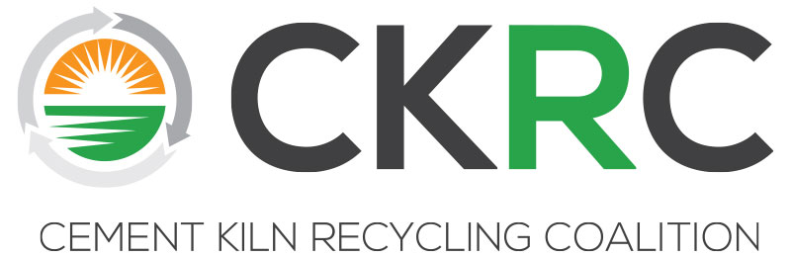

CKRC Spring 2019 Meeting
April 1- 3, 2019
The Wigwam Hotel
300 East Wigwam Blvd., Litchfield Park, Arizona 85340, 866.976.6894

Agenda

MONDAY, April 1 (Palo Verde Room)
3:00-5:00 pm Executive Committee Meeting (See Separate Agenda sent to EC)
6:00 pm Welcome Reception and Dinner (Sachem Terrace)

TUESDAY, April 2 (Sachem West Foyer)
7:00 am Breakfast Buffet Available
8:00 am Call to Order/Antitrust/EC Update
8:15 am The Fight to Control Policy and Politics in 2019: Energy and Manufacturing Caught in the Crossfire
Joshua Zive – Senior Principal, Bracewell, LLP
9:15 am RCRA/CERLCA Update -- Jim Berlow - Consultant
        - RCRA Budget Cuts/Priorities
        - PFOS/PFAS Designated Hazardous Substances Under CERCLA/Subsequent Implications for RCRA
        - CERCLA Financial Assurance Oral Arguments on Hardrock Mining
        - eManifest – 2/8 FR Proposed Amendments to Manifest Form (comments due April 9th)

9:45 am Break
10:00 am Legal Update -- Lisa Jaeger – Senior Counsel, Bracewell, LLP
- Administration Notes of Interest
- CAA
  - Utility MACT Cases
  - MACT/RTR Rules
  - Testing Regulations for Air Emission Sources
  - RMP Rule
  - Once In, Always In
  - New Source Review/PSD Reform
- OSHA Silica Rule
- CWA
  - Waters of the US
  - CWA Groundwater/Point Source
- RCRA
  - Definition of Solid Waste
  - Hazardous Waste Generator Improvements Rule
- CERCLA 108(b) Financial Assurance
- Environmental Liability NEXTGEN
- NEPA
- Endangered Species Act/ Administrative Law

11:00 am Guest Speaker: Terry Baer – Manager, Solid and Hazardous Waste Section
Arizona Dept. of Environmental Quality (AZDEQ)
12:00 noon Lunch
12:45 pm eManifest Implementation Work Session (Michelle Lusk, Jim Berlow, Members)
          - Summary of Implementation Issues of Concern Identified by CKRC Members
          - Discussion and Assessment of those Issues/Solutions
          - Identify Consensus Issues/Solutions and Develop Recommendations to EC Regarding a Potential Meeting with EPA

1:45 pm Break

1:55 pm Technical/Regulatory Committee (Steve Reale, Mike Harrell, Michelle Lusk)

Due to recent inspection activity at member companies, the Technical/Regulatory committee has been asked to lead a discussion on how leak detection and repair (LDAR) requirements are being implemented within the membership. There are a number of challenges with current monitoring technologies. The key issues revolve around the type of instrument used to perform Method 21 leak inspections, the calibration of these instruments, and the technical limitations of each instrument. We will seek to identify common approaches within the industry and evaluate the need to recommend to the EC approaching EPA collectively to change the regulation, request waivers and/or provide guidance clarifying the requirements.
- LDAR Monitoring Requirements
          - Recent inspections at Member Plants under the National Enforcement Initiative (now called National Compliance Initiative)
          - Equipment and Calibration Gas Requirements (Method 21 requirements)
          - Industry Waivers
          - Need for clarification of requirements or guidance?

- Summary of CKRC/MSHA Meeting in December

- Committee Issue Brainstorming/Interests/Priorities

3:00 pm Adjourn Meeting

3:30pm-7:30 pm Depart from The Wigwam Hotel Lobby
Industry Networking Adventure (dress very casual, closed toe shoes such as hiking boots or sneakers are required for desert tour, no sandals/flip flops)

Industry Networking Adventure Description
Participants will take part in a Premier Off-Road Vehicle Guided Tour of the Tonto National Forest on the Four Peaks Trail. Experienced and knowledgeable guides will easily conquer intense desert terrain (12 passengers per vehicle) while discussing the wildlife and plants that inhabit a majestic landscape. Stops will be made and the desert tour will end with an unmatched view of the desert sunset. Participants will have an opportunity to spend time with fellow industry professionals, talk one-on-one about important issues, and enjoy an unforgettable adventure in the Sonoran Desert. Refreshments will be provided. Reservations have to be exact be sure to secure your seat so be sure you registered your participation in this event prior to the meeting.

TUESDAY NIGHT, April 2 (Outdoors in the Trellis Garden)
7:30 pm Cowboy Cookout Reception/Buffet Dinner

WEDNESDAY, April 3 (Sachem West)
7:30 am Buffet Breakfast Available (Sachem West Foyer)
8:00 am Technical/Regulatory Workshop Part II: Diving Deeper into Select Topics
Exploring the Regulatory Building Blocks of Energy Recovery: HOW and WHY we do what we do! #PasstheTorch
Presenters will include Bob Schreiber and Steve Reale with Trinity/SYA and the Group will Cover the following Topics:
- Understanding the implications of being a Subpart EEE source at all times and how to define Subpart LLL Applicability
- Implementation of 40 CFR 266.112, managing site generated waste and recovering old piles
- Energy Recovery, 5000 Btu and impermissible dilution
- Subpart AA, BB, CC, DD related Issues

12:00 noon Adjourn/Boxed Lunches Available
1:00 pm Golf Outing –Robert Trent Jones Blue Course (please register with CKRC)
Individuals pay on own at the course ($92+tax per golfer, Rental Clubs are $55+tax and includes six golf balls).

