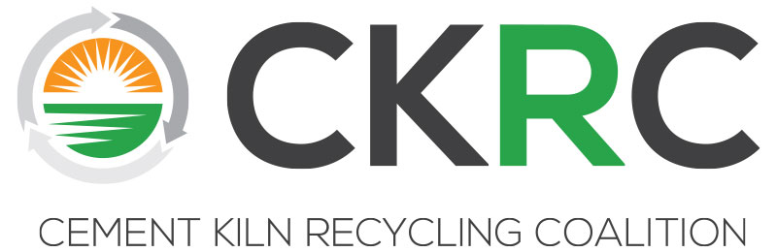

CKRC Technical/Regulatory Workshop

Exploring the Regulatory Building Blocks of Energy Recovery:
HOW and WHY we do what we do!
# PasstheTorch

Part II: Diving Deeper into the Issues

Wednesday, April 4, 2019

