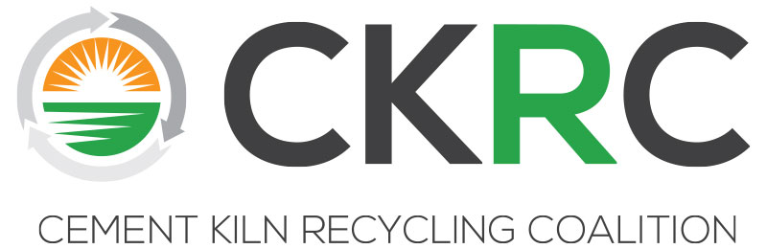
CKRC Executive Committee Meeting
Wednesday, October 23, 2019 * 3:00-6:00 pm
The DeSoto Hotel – Savannah, GA
15 East Liberty Street, Savannah, GA 31401
Lafayette Suite
Agenda

I Call to Order/Antitrust Agreement and Welcome
(Michelle Ferguson) 3:00pm

II Approval of EC Spring Meeting Minutes, June Conference Call Minutes (Committee) 3:05pm

III Financial Reports (Michelle Lusk) 3:10pm
- Final BvA FY 2018/19
- Dues Payment Report (Receivables)
- Current Budget vs Actual 2019/20

IV Progress Update on Scholarship in Craig Campbell’s Memory (Michelle Lusk) 3:20pm

V Exxon/API Request Regarding Non-conditional Delisting for Refining Industry (Michelle Lusk) 3:30pm

VI July MSHA HQ Meeting Update (Michelle Lusk) 3:40pm

VII CKRC’s 2004 Petition Challenging the PS-11 Final Rule (Lisa Jaeger) 4:00pm

VIII Upcoming Meetings – (Michelle Lusk) 4:30pm

- Spring 2020 – Monday, April 20th-Tuesday, April 21st
The Kimpton Lorien Hotel, Alexandria, VA
(Discuss IEEE Conflict with this date)

- Fall 2020?

IX New Business (Committee) 4:45pm

X Adjournment (Michelle Ferguson) 5:00pm

On Thursday morning, Chairman Holt will conduct a members only meeting from 8am to 8:55am in a private room separate from the full membership meeting which will be called to order at 9am. Logistics for the morning meeting will be shared before we adjourn the Wednesday afternoon meeting.

