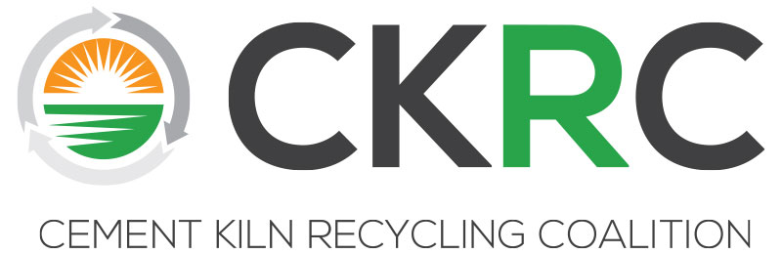

CKRC Executive Committee Meeting
Monday, April 1, 2019 * 3:00-5:00 pm
The Wigwam Hotel -- Palo Verde Room
300 East Wigwam Blvd., Litchfield Park, Arizona 85340, 866.976.6894

DRAFT Minutes

Attendees- T. Schlosser, C. Lesslie, D. Nugent, M. Harrell, J. Marini, B. Schreiber, L. Smith, S. Reale, K. Derksen, M. Ferguson, M. Lusk

I Call to Order/Antitrust Agreement and Welcome -- In Chairman Holt’s absence, Vice Chairman Curtis Lesslie called the meeting to order and reminded the group the meeting would be conducted in accordance with CKRC’s antitrust statement and in accordance with all CKRC policies.

II Approval of EC Minutes Fall 2018 – The draft CKRC Executive Committee Meeting minutes from the fall 2018 meeting in Lansdowne, VA were presented for approval. D. Nugent moved to approve minutes pending a typo correction that had already been identified, T. Matz seconded it, and the motion carried unanimously.

III Financial Reports -- Michelle Lusk reviewed the Dues Payment Report (Receivables) reflecting that all CKRC member dues are paid in full. She then presented the Budget vs Actual showing that all categories look to be fairly on track. She noted that the meetings appear higher than normal to date due in part to having two technical meeting/workshops this fiscal year and the fact that down payments for upcoming meetings were made earlier than usual because of a staff/EC effort to plan meetings further in advance.

IV Financial Exploratory Task Force Recommendation -- Task force co-chairs Michelle Ferguson and Dan Nugent presented the concept of a cash surplus dues rebate. M. Ferguson presented an updated cash flow analysis to explain how the rebate process could work and demonstrating that it appears CKRC’s financial outlook could support such a concept. J. Marini requested the analysis be updated to include a 3-year projection. M. Ferguson agreed to update the analysis and work with staff to prepare a written proposal for the EC’s review and discussion as part of the Executive Committee FY19/20 budget proposal conference call in June.

V Progress Update on Scholarship in Craig Campbell’s Memory – M. Lusk reviewed the EC decision to fund the first half of the Craig S. Campbell memorial scholarship using the remaining funds in CKRC’s inactive PAC. The second half will come from CKRC’s budget in years 3 and 4. M. Lusk is currently working under the guidance of Bracewell to file the necessary paperwork to shutter the PAC and receive official approval to use those funds for the memorial scholarship at Bucknell. This should all be accomplished by June so the scholarship will be awarded for the 2019/2020 academic year.

VI December MSHA Meeting Update -- Michelle Lusk and Curtis Lesslie summarized the meeting and communicated that it was a positive exchange. M. Lusk provided summary notes and asked for any feedback/comments be sent to her following the meeting. The group noted that Mike Davis retired soon after the meeting. To date, there has been no follow up requests from the agency nor CKRC interactions since the meeting occurred.

VII Update on March USEPA Exploratory Meeting on Potential Voluntary Confiscated Drug Initiative (CDI) -- Dan Nugent and Michelle Lusk summarized the exploratory meeting they had with Barnes Johnson and his staff. Some initial challenges include the ability to characterize what is in the CD wastes and transportation of these wastes to facilities. If there is interest from members, the next step would be to have the Technical/Regulatory committee review some of the information the Agency provided and determine if it provides enough detail to characterize the CDI wastes and better identify constituents of concern to the membership.

VIII Technical/Regulatory Workshops – Mike Harrell and Michelle Lusk discussed additional ways to get valuable technical/regulatory information shared over the last few workshops to a broader audience (beyond those that attend CKRC meetings). One idea shared was to conduct issue-specific webinars. A variety of potential topics were thrown out. In order to gauge interest, M. Lusk suggested staff could develop an inquiry memo and share it with member companies. Based on member interest, staff could then look into cost/logistics to host topic-specific webinars and determine if any budget recommendations need to be made. The group also discussed having the ability to “save” the webinar events and make them available for future viewing.

IX Upcoming Meetings – Michelle Lusk announced the dates and locations for the next two CKRC member meetings. The Fall 2020 meeting location/plans will be discussed at the next meeting in GA.

- Fall 2019 – Wednesday, October 23rd-Friday, October 25th
The Desoto Hotel, Savannah, GA

- Spring 2020 – Monday, April 20th-Tuesday, April 21st
The Kimpton Lorien Hotel, Alexandria, VA

X New Business – There was no new business raised.

XI Adjournment -- D. Nugent moved to adjourn the meeting, T. Schlosser seconded the motion and it passed unanimously.

