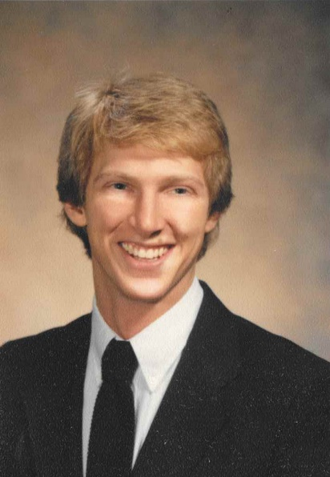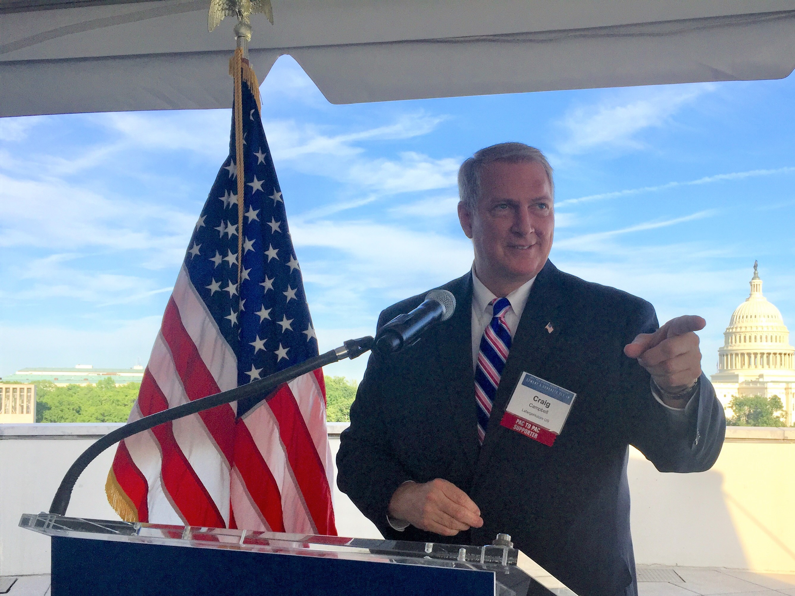
Craig S. Campbell Scholarship

Craig S. Campbell (1965-2017) was a wise and strategic-thinking industry leader, loving family man, respected colleague and dedicated friend. He served as a vital part of the Cement Kiln Recycling Coalition (CKRC) in a variety of capacities for over 25 years. He was on CKRC’s staff in the early 90s as our environmental technical director and then served on CKRC’s Executive Committee as treasurer, Vice Chairman and multiple terms as Chairman after he became an Executive at one of CKRC’s member companies. He was an admired mentor and always encouraged those around him to work hard, achieve educational goals, and be successful. He placed a high value on education and was extremely proud to be a Bison alumnus. He graduated from Bucknell University in 1987 with a degree in Chemical Engineering.

Because words cannot adequately express how much he will be missed both personally and professionally by all of us that called him our friend and colleague, CKRC decided to set up the Craig S. Campbell Scholarship at his alma mater to honor his memory. Bucknell will award this one-time 4 year scholarship to a student in the College of Engineering on the basis of financial need without further restrictions.

